Shop Local Shop Handmade

Homemade Homegrown Handcrafted Vintage Baked Goods
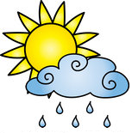
Saturday May 5 , June 2, September 1, October 6, and November 3
9am – 4pm

Summerseat Farm, Inc.
26655 Three Notch Road,
Mechanicsville, MD

Summerseat Farm, Inc. is a 501(c)3 nonprofit organization dedicated to preserving the estate’s historic splendor & natural resources. Run entirely by volunteers, the farm relies heavily on grants, memberships, donations, & fundraisers to keep the farm running.
All donations are fully tax deductible.

FOR VENDOR INFORMATION, GUIDELINES, AND APPLICATIONS, VISIT
WWW.SUMMERSEAT.ORG

