SUMAC, POISONOUS OR NOT??

A recent confusion at Summerseat Farm between Sumac and the poisonous variety of Sumac
prompted me to do some research on these two native plants and share what I learned with you; since the cooler temperatures of fall are bringing out the vivid shades of red to maroon and gold of the Nonpoison Sumac and the yellows, pinks, reds and oranges of the Poison Sumac. The plants are catching attention and prompting questions.

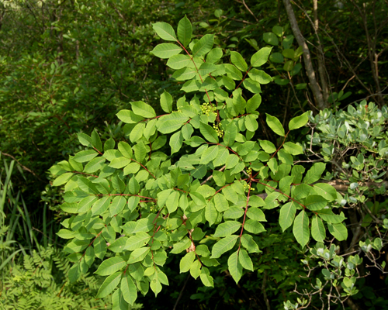
SUMAC is one of the most underrated bushes for providing fall color in the landscape. This is due mostly to the fact that when homeowners hear the word “sumac,” they jump to the conclusion that the plant is “poison sumac.” But Poison Sumac would hardly ever be found
in a front yard. Poison Sumac thrives in wet soil conditions such as
marshes, swamps, and river and pond shorelines. This shrub (some-
times considered a small tree) grows among the ferns, cattails and
winterberry of swampy areas.

All parts of Poison Sumac are poisonous, so it’s good to identify the plant properly. It is indigenous to eastern North America.
Poison Sumac Shrub

Sumac has a pinnately compound leaf. Pinnate means resembling a feather. Compound means a plant’s leaf is composed of multiple leaflets joined by stems. Leaves are made up of from 5 to 13 such leaflets, always an odd number. While most of the leaflets form matching pairs, there’s always a lone leaf at the tip of the compound leaf giving it the shape of a feather.

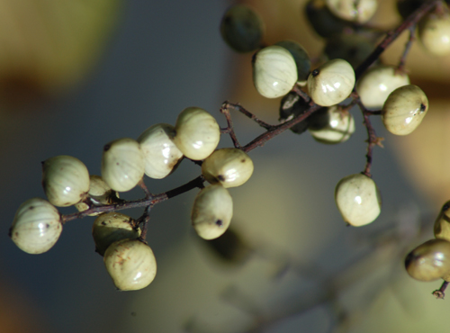
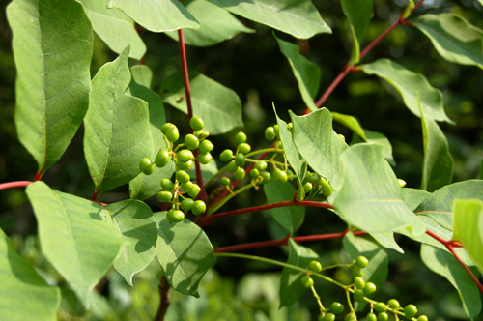
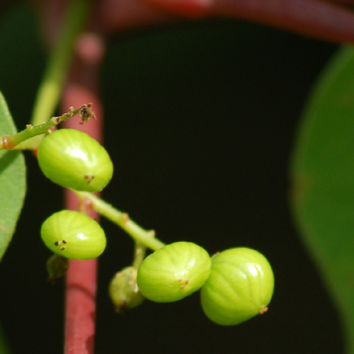
Berries start out green in spring maturing
to a whitish color. The Poison Sumac berry
cluster is quite distinct from the berry cluster
of nonpoisonous sumacs, in terms of color, shape and texture. Berries aren’t perfectly round. Toxic to the touch to humans, they’re not toxic to birds. Birds and quail treat these
berries as an emergency food source in winter. Three views of Poison Sumac Berries
Comparing the berries is the easiest way to
distinguish poison from nonpoison sumac.

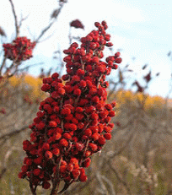
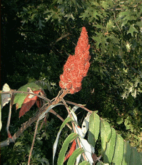
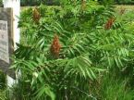
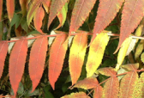
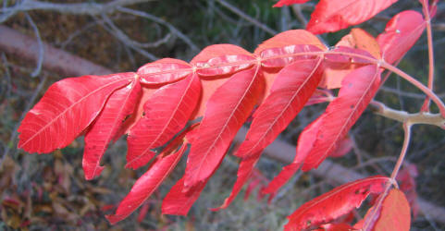
Sumac foliage changes color in the fall. The seed tuft of Non-poison Sumac is vivid red. This sumac can be a potentially
desirable landscape element. It furnishes outstanding fall color
without the poisonous element. One of the easiest ways to distinguish the plants are the seeds. They are quite different. Nonpoisonous sumac berries grow in red, fuzzy seed tufts which look feathery from a distance and are soft to the touch. Seeds are tightly packed in the seed tufts as shown in some of these five pictures of Nonpoisonous Sumac.
Poison Sumac is sometimes nicknamed Poison Dogwood. Older bark is much rougher in texture than the newer bark. Shrubs grow to 6 to 20 feet high. The red stems help identify Poison Sumac.
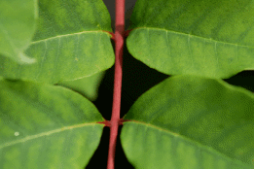
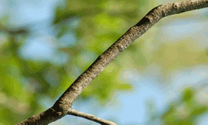
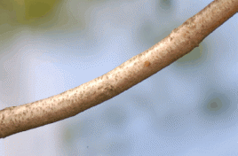
Look for them
first thing in the
spring.

Three views of Poison Sumac branches

Poison Sumac provides a striking array of color in the fall with shades of yellow, gold, pink and red as shown below.

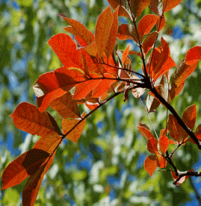
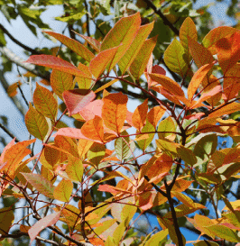
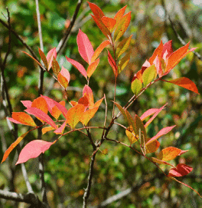
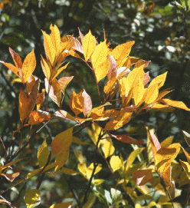

Poison Sumac contains an oily, toxic substance “urushiol” present in the plant throughout the year. Contact with this substance causes irritation, itching and blistering of the skin, similar to the response to Poison Ivy.

Sumac Trees (or bushes), which have been scorned for so long because of their association with Poison Sumac, deserve a second and closer look. As beautiful as the fall display of Nonpoison Sumac, they are no longer just something pretty to look at. They are starting to become a part of landscaping projects around the home, now that the difference is better understood. I hope that this little article has cleared up any misconceptions you have harbored over the years about Nonpoison Sumac.

Sandy Woolard, Chairman, Garden and Landscape Committee
October 1, 2009

